ROUNDTABLE HINTS
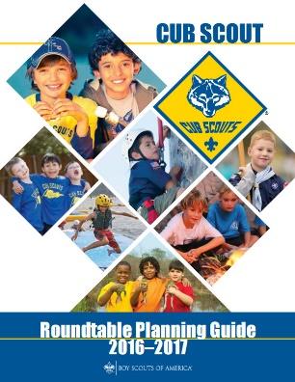

ABOUT THE 17-18 RT PLANNING GUIDES

Usually the Cub Scout and Boy Scout Roundtable Planning Guides (RT PG) are issued at the BSA’s National Meeting which occurs annually near the end of May. This did not happen this year. For different reasons both RT PGs are delayed.
The BS RT PG is in final review. There were several personal events amongst the reviewers (e.g. deaths in family) that delayed the review. My fellow instructor and ACC-RTs, George Costigan, told me that all is set once final reviews are done. And I Thank him for asking me to join his team this year.
The CS RT PG appears to be further behind. I have unofficially seen drafts of the agendas and materials for the 12 months and there is good stuff planned to be presented. The topics selected are meaningful for Cub Scout Leaders.
I will be looking for the finished products so I can keep y’all informed. (About the “y’all” - Thank you to J. Clay Dean and Jimmy Phillips from Alabama and members of my patrol at Schiff Scout Reservation for NJLITC in 1963 with Mr. Walker, SM, and Ron Geddes, SPL.) informed.

